Exercises RESOLUTION

Using general resolution prove that the following formulas are theorems.
- ;
2. ;
- ;
- ;
- ;
- ;
- ;
- .

Using lock resolution check the inconsistency of the following sets of clauses. Choose two different indexings for the literals:
- ;
- ;
- ;
- ;
- ;
- ;
- ;
- .
        - Build a linear refutation from the following set of clauses:
- 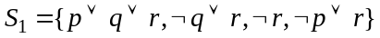;
- ;
- 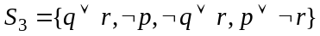;
- ;
- ;
- ;
- ;
- .

Prove the consistency of the following sets of clauses.
- ;
- ;
- ;
- ;
- ;
- ;
- ;
- .

Using the set-of-support strategy prove the following deductions:
- ;
- 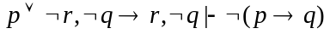;
- 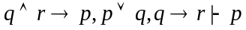;
- 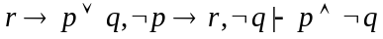;
- 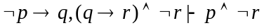;
- 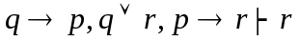;
- ;
- .

Prove the inconsistency of the following set of clauses using lock resolution.
Try two different indexings for the literals.
- ;
- ;
- ;
- ;
- ;
- ;
- EMBED Equation.3 .

Prove the following deductions using linear resolution
- 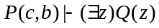;
- ;
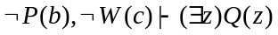;
- ;
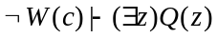;
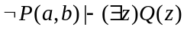;
- ;
- .

Using a refinement of predicate resolution prove:
- the semidistributivity of ‘’ over ‘’:
and

- the semidistributivity of ‘’ over ‘’:
and

- ;

- the distributivity of ‘’ over ‘’:
;

- ;

- the semidistributivity of ‘’ over ‘’:
and

- ;

- the distributivity of ‘’ over ‘’:
.

Check whether the following formulas are theorems using lock resolution.
- ;
- ;
- ;
- ;
- ;
- ;
- ;
- .

